**Ultrasonic Alarm Circuit**

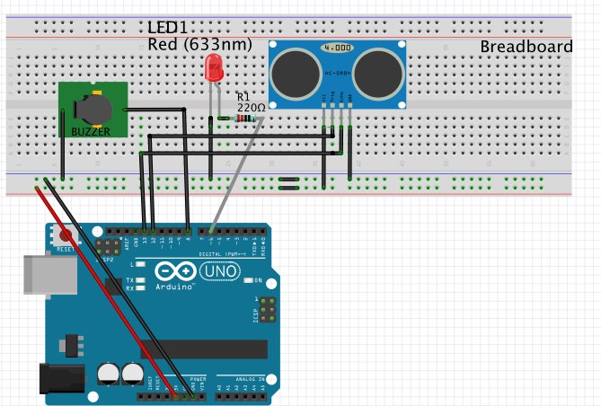

/* This simple project describes how to make an ultrasonic alarm system using

LED, Ultasonic Sensor(HC-SR04) and a buzzer.*/

//First the connections of ultrasonic sensor connect +5v and GND normally and trigger pin to 12

//& echo pin to 13.

#define trigPin 12

#define echoPin 13

int Buzzer = 8; // Connect buzzer pin to 8

int ledPin= 6; //Connect LEd pin to 6

int duration, distance; //to measure the distance and time taken

void setup() {

Serial.begin (9600);

//Define the output and input objects(devices)

pinMode(trigPin, OUTPUT);

pinMode(echoPin, INPUT);

pinMode(Buzzer, OUTPUT);

pinMode(ledPin, OUTPUT);

}

void loop() {

digitalWrite(trigPin, HIGH);

delayMicroseconds(10);

digitalWrite(trigPin, LOW);

duration = pulseIn(echoPin, HIGH);

distance = (duration/2) / 29.1;

//when object is more than 30 cm, the buzzer and LED are off

if (distance >= 30){

Serial.println("no object detected");

digitalWrite(Buzzer,LOW);

digitalWrite(ledPin,LOW);

noTone(Buzzer);

}

else {

Serial.println("object detected \n");

Serial.print("distance= ");

Serial.println(distance); //prints the distance if it is between the range 0 to 30 cm

tone(Buzzer,400); // play tone of 400Hz

digitalWrite(ledPin,HIGH);

}

}